**University of Central Florida**

College of Engineering and Computer Science



**Fall 2020**

**Project and Group Identification Document, Version 2.0**

**The Automatic Pill Dispenser**

**Group 18:**

Steven Hudson - CpE

Dakota Riediger Downing - CpE

Eduardo Noguera - CpE

Nestor Vallejos - CpE

**Project Narrative**

This project aims to help elderly people and sick people who have to take pills daily but may have some other sort of dysfunction that makes it difficult for them to sort their pills, get their pills out of the pill sorter, or remember to take their pills. Such dysfunctions that can make taking pills difficult from a traditional pill sorter are arthritis, dementia, or any other illness that may make it hard for the person to remember to take their pills or physically open their pill organizer. We want to build an automatic pill dispenser that sorts and dispenses a person's pills at the push of a button and reminds the person to take the pills. There seems to be a couple of similar products on the market but they are expensive, do not sort the pills for you, and require a monthly subscription fee. Some competing products include;

* Hero Health automatic pill dispenser
  + $30 starting + $29.99 a month subscription.
  + <https://herohealth.com/>
  + 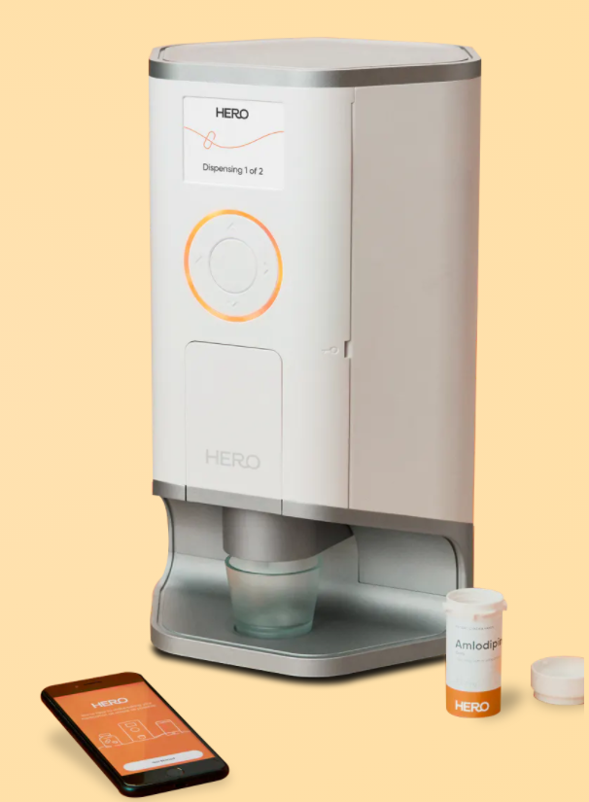Figure 1 (Hero Pill Dispenser)
* Pria automatic pill dispenser by Black and Decker
  + $450 + $9.99 monthly subscription
  + <https://www.blackanddecker.com/products/product-stories/pria>
  + 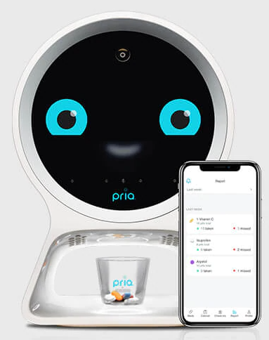Figure 2 (Pria Pill Dispenser)

We aim to create an easy to use, lower cost, small physical footprint device that sorts the pills and automatically dispenses them for the user daily. This will be done by building the device and using it with an mobile application that can send notifications to both the user and a caretaker. These notifications will notify the user to remember to take their pills, and if they don’t then it will notify the caretaker that they did not take their pills. The mobile app will be fairly simple. The user will enter the phone number of both the user and the caretaker, along with the medications that they take. For our MVP, we do not plan on having the pills automatically sort. However, if we have the time to move forward with a 2.0, we would like to automatically sort pills by having the user enter what medication they take on what days and having the pill machine sort the pills for you using object detection.

The examples above come with a hefty subscription price, in particular Hero (figure 1) is priced at $39.99 a month and Pria (figure 2) is priced at $9.99 a month. This is on top of what is already paid upfront. The goal would be to create something price efficient enough that the upfront cost of our design would allow us to receive a nice enough profit (in theory) from each pill dispenser that the cost of running the server is outweighed.

**Project Requirements, Specifications, and Constraints**

**Requirements and Specifications**

For this project we have set the following requirements;

1. The device will sort pills automatically into the corresponding days according to what the user puts into the app.
2. Includes a mobile application that;
   1. Allows the user to input settings for sorting.
   2. Sends notifications to both user and caretaker about the status of the day's pills.
3. The device will have a linear guide rail that rolls back and forth.
4. The device will use servo motors.
5. The device will use buttons.
6. A small physical footprint housing of 1 ½ by 1 ½ feet.
7. A small 2.5 - 5 inch lcd display for displaying important information.
8. An easy to access system for pill access.
9. A TI microprocessor.

**Constraints**

We foresee the following constraints when working on this project

* Creating a Prototype:
  + Due to Covid-19, the ability to assemble a prototype might prove difficulty.
* Making Decisions to Benefit the Customer:
  + Like whether to make it automated by sensor or a push of a button.
  + As well as, making it sort all the medications for the customer.
* Time Management:
  + If we decide to take a path for this project that is very time consuming, we might run into an issue where we would need to throw out a singular functionality of the device.
* TeamWork:
  + It is possible that everyone on the team could not be on the same page which could lead to delays.
* Learning Curve:
  + Even though most of us have some experience with the equipment we will need to create the device, we will still need to learn other operations in order to get the desired outcome.
* Money:
  + As college students, especially during a pandemic, money is scarce, so having enough to purchase all the materials might prove difficult, and might cause others to pay more than the other members.
* Design:
  + This product needs to be as user friendly as possible, so we might have to sacrifice or over extend some features to accommodate those needs.

**Mobile Application Layout**

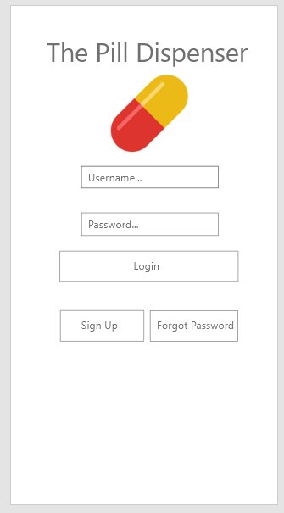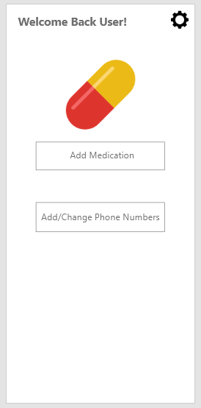

Figure 3 (Login Page) Figure 4 (Home Page)

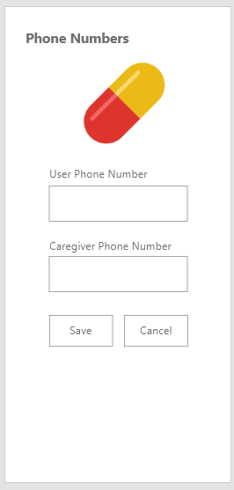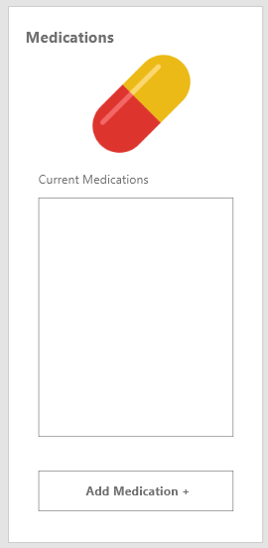

Figure 5 (Phone Numbers Page) Figure 6 (Medications Page)

The mobile application is going to be built on a MERN stack. This means we will use MongoBD for the database, Express for building the API, React Native for the front end design, and Node for server communication. We are still currently looking for a good hosting solution for the application. Amazon Web Services, Google Cloud, and Heroku are all very good options.

Features for the mobile app include;

* Sign in and Sign out
* Sign up and password reset.
* Input caregiver phone number and user phone number.
* Schedule time to take pills.
* Send out text reminders at that time to the user and caregiver.
* Send out text messages to the caregiver if pills are not removed from the pill tray.
* Add a medication to the list of medications being taken at what day/time

Excluded from the figures above are the modals that will popup with form elements to fill out when adding a medication (figure 6), signing up (figure 1), or going through the forgot password process (figure 1).

After developing mobile software in previous classes, we as a team are confident we have the skills to build out the mobile application.

We decided to move forward with a MERN stack because we have the most experience with it when it comes to mobile software. MongoDB offers great data flexibility and using an all JavaScript stack means we do not need the knowledge of several languages for backend and front development of the application.

**Block Diagram**

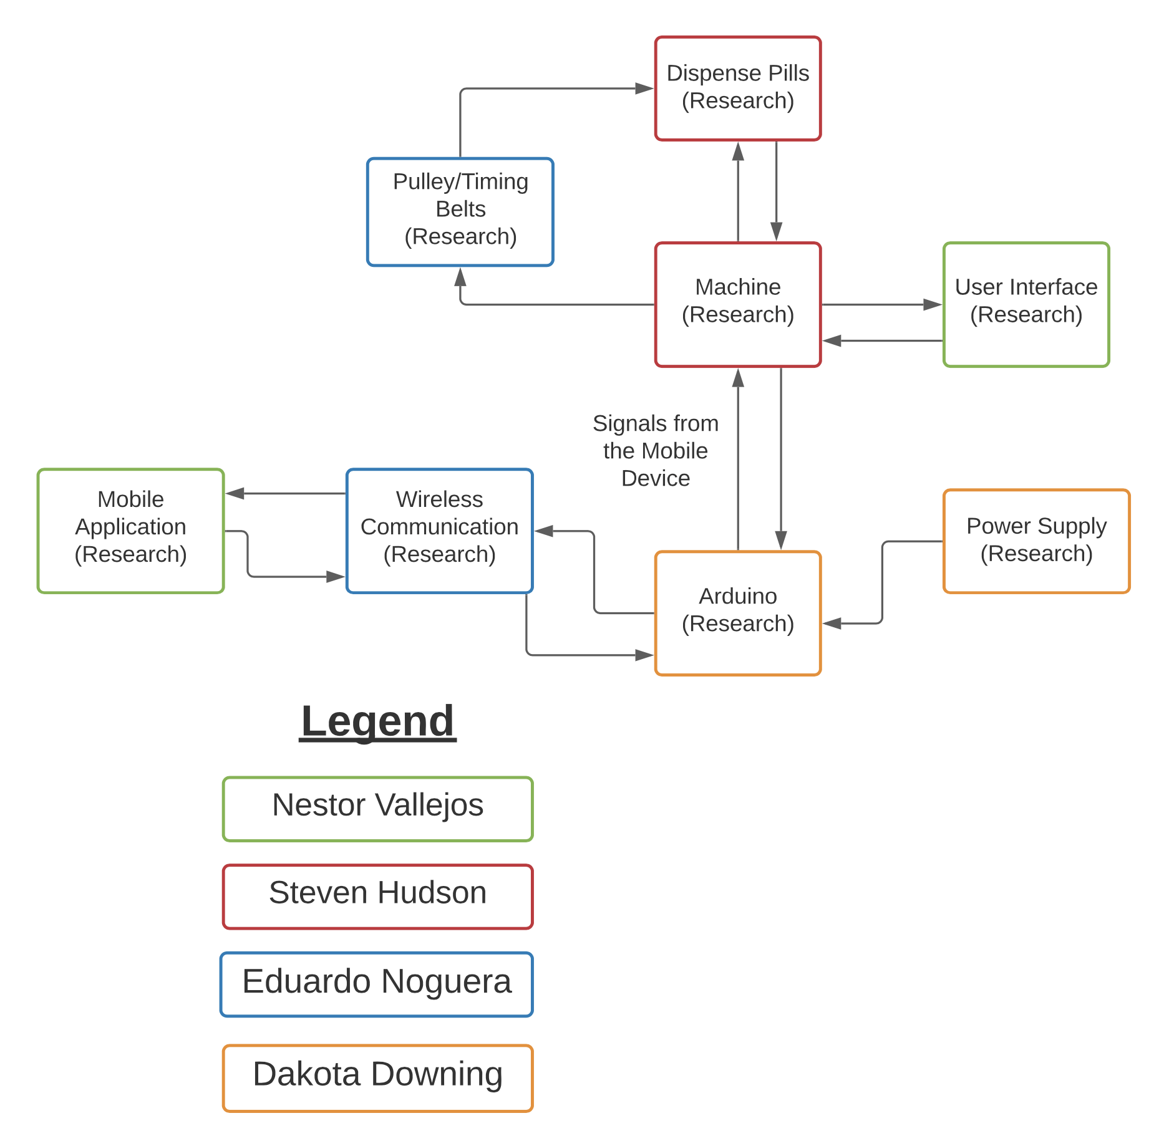

Figure 7 (Workflow Diagram)

**Project Budget**

It is difficult to see what the final dollar value will be when the project is said and finished. However I would like to set a budget of $500. To achieve the most feature packed version of this product, it would require;

1. A web hosting service - $30
2. Ti microprocessing board - $80
3. 2.5 to 5 inch lcd display - $100
4. Servo motors - $50
5. Stepper motors - $25
6. Breadboard and wires - $20
7. Pulleys and timing belts - $20
8. Breadboard setup and wires - Stepper motor drive controller(s) - $20
9. Various enclosures/pill holder - $50
10. Linear guide rail system - $30

This leaves approximately $100 for unexpected expenses that may appear throughout the design and build process of the project. As with any project, we are in the very early stages of planning and are unsure of the unexpected expenses that may come so it is always good to plan for unexpected expenses in the budget.

**Project Milestones**

**Fall Semester;**

* Research has been done and there is a clear path forward on planning and designing
* We have an idea of what the final product looks like and we can begin planning.
* We have done an initial buy of some of the parts as well as have the programming and “how it works” portion figured out.
* We have started working on some individual portions of it (i.e. we have a small working example of how the pills will be sorted).
* Planning is done.
* We have begun designing the chassis.

**Spring Semester;**

* We have printed the chassis and have the parts ready.
* Our mobile app is mostly done and we have established the connection between the pill sorter and the mobile app.
* We have put the parts together and into the printed chassis.
* We have a final working prototype.
* We have a final product that has been tested.

**Decision Matrix**

In the process of coming up with this project idea, we ran through a lot of other project ideas that we decided not to go with, either based on group indecisiveness or whether the project was even possible. These ideas include;

1. A humanless COVID temperature checkpoint.
   1. Not every member was crazy about the idea
   2. Was not sure how we could set it apart from what already exists.
2. A paperless receipt transaction that works with any POS system.
   1. Not much hardware involved.
   2. Do not know enough to know if this idea was even possible.
3. Finance Tracking App
   1. Was purely software related, more of a CS idea.
4. Universal Wireless Smart Lock - Adjustable size smart lock that goes over an existing door lock and is Google/Alexa enabled.
   1. Ultimately this idea may be difficult to satisfy the “universal” aspect of it considering all locks shapes and sizes.
   2. Would only apply to dead bolts.